# Module 4: Advanced Docker

This module builds on what you learned in Module 2. While most of what you'll do in this module isn't something you'll do when supporting Azure App Service, it will help you to have a more thorough understanding of Docker and building Docker images.

## Prerequisites

The following prerequisites are necessary before participating in this Boot Camp.

* A local Docker Community Edition (CE) install. You can find it at https://www.docker.com/community-edition.
* A free GitHub account.
* A free Docker Hub account.

## Goal

After completing this Boot Camp, you will have achieved a Level 200 skill set in:

* Building Docker images from the command line, automated build, and Docker Commit.
* Using Dockerfiles and .dockerignore to automate tasks while building a Docker image.
* Understanding Kubernetes and Docker Compose multi-container deployments.

# Docker Images

Before you can start a Docker container, you need a Docker image. There are a few different ways to create a Docker image.

* You can use docker build to create an image using a *Dockerfile*.
* You can use docker commit to create an image from changes you've made to an existing Docker container.
* You can use the automated build features in Docker Hub to create an image when you push changes from a source code repository.

In this module, we'll cover all these techniques.

# Creating an Image Using docker build

When you create a Docker image using docker build, you provide Docker with a *Dockerfile* and a build *context*. A Dockerfile is a text file that tells Docker how to build the image. The context is one or more files located at a path or a URL.

|  |  |
| --- | --- |
| C:\Users\james\AppData\Local\Temp\SNAGHTML310f382.PNG | See **The Dockerfile** later in this module for details on what is contained in a Dockerfile. |

The path can point to a specific directory, but it can also simply be a period. When using a period as the path, the context will consist of all the files in the current directory and its subdirectories. For example:

|  |
| --- |
| $ docker build /assets/website |

-- or --

|  |
| --- |
| $ docker build . |

You can also specify your image name and an optional tag. For example, the following will create a Docker image called *MyImage* with a tag of *v1*.

|  |
| --- |
| $ docker build -t MyImage:v1 . |

A URL can either be a URL to a Git repository or a URL that points to a remote tarball. For example:

|  |
| --- |
| $ docker build https://github.com/jamesche/officewebsite |

-- or --

|  |
| --- |
| $ docker build http://mysite.com/docs.tar.gz |

When you run the build command, Docker will send the files to the Docker daemon and it will use those files as the context.

|  |  |
| --- | --- |
| C:\Users\james\AppData\Local\Temp\SNAGHTML53be59c.PNG | You must have a Dockerfile in the path or in the root of your repository. Otherwise, you will see an error. |

## The Dockerfile

As stated earlier, a Dockerfile is simply a text file that contains the information necessary to build an image. A Dockerfile consists of one or more instructions the Docker daemon uses to build an image.

|  |  |
| --- | --- |
| C:\Users\james\AppData\Local\Temp\SNAGHTML53be59c.PNG | Your Dockerfile cannot be empty. If it is, an error will occur when you try to build your image. |

### The FROM Instruction

Your Dockerfile must have at least one FROM instruction. The FROM instruction specifies the image your Docker image is based upon. For example, if you want to base your image on the official Ubuntu image in Docker Hub, your Dockerfile would start with:

|  |
| --- |
| FROM ubuntu |

Note that the repository name must be all lowercase.

|  |  |
| --- | --- |
| C:\Users\james\AppData\Local\Temp\SNAGHTML53be59c.PNG | The image specified in the FROM instruction is referred to as the *parent image* of your image. You'll sometimes see people (including Docker documentation) refer to it as the *base image*, but technically, it's not the base image.  See **The Chicken or the Egg - Parent and Base Images** later in this module for more details. |

If your Dockerfile contains nothing else other than this single FROM instruction, your image will be a duplicate of the Ubuntu image. However, most of the time, you'll want to add additional instructions to your Dockerfile. For example, you might want files that are in your build context to be added to your image. (We'll cover more on that later in the **Adding Files from the Context** section.)

|  |  |
| --- | --- |
| C:\Users\james\AppData\Local\Temp\SNAGHTML53be59c.PNG | Docker recommends the Alpine image as a parent image. It's lightweight and has a complete package index, so it's easy to add what you want without too much overhead. |

### The Chicken or the Egg - Parent and Base Images

If you're really paying attention, you might be asking a question at this point. If you *must* have a FROM instruction, how did the creator of the Ubuntu Docker image create that image? The Ubuntu image isn't based on another image. It's simply the Ubuntu OS packaged into a Docker image.

A Docker image that has no parent image is called a *base image*. You create a base image by using the following FROM instruction in your Dockerfile.

|  |
| --- |
| FROM scratch |

This instruction specifies that the image doesn't have a parent image it's based upon. It's a completely fresh image.

By the way, the official Docker documentation says a base image can be created by including a Dockerfile without a FROM instruction. This is untrue. Docker requires your Dockerfile have at least one FROM instruction.

### Multiple Parents

Your image can have (and often will have) more than one parent image. For example, suppose you not only want to create an image based on the Ubuntu image, but you also want that image to have Apache included in it. To accomplish that, your Dockerfile might have the following FROM instructions.

|  |
| --- |
| FROM ubuntu  FROM httpd # The Apache HTTP Server Project |

The "#" character you see in the above example is a comment character. Anything that appears after the "#" is considered a comment. This is an excellent way to document your Dockerfiles.

### Adding Files from the Context

As you learned earlier, when you run docker build, Docker transfers the files in the context to the Docker daemon. What you might not have realized is the transfer of these files simply makes them available to the Docker daemon. It doesn't copy any of those files into your Docker image. To add files from the context into your image, you need instructions in your Dockerfile.

To add files from the context to your image, you can use the ADD or COPY instruction. For example:

|  |
| --- |
| COPY index.html /var/www/html |

The ADD instruction is similar, but it has additional capabilities. Most commonly, ADD is used when you want to extract a tar file into your image. For example, the following two instructions do something completely different.

|  |
| --- |
| COPY bigfiles.tar.xz /bigfiles  ADD bigfiles.tar.xz /bigfiles |

The COPY instruction will copy the bigfiles.tar.xz file to the bigfiles directory in my image. The ADD instruction, on the other hand, will auto-extract the bigfiles.tar.xz file into the bigfiles directory in my image.

### Running Commands

Another common instruction used in Dockerfiles is the RUN instruction. The RUN instruction runs a command. This is commonly used to install components in the container or to change permissions on files. For example, consider the following snippet from a Dockerfile.

|  |
| --- |
| RUN apt-get update  RUN apt-get install -y --no-install-recommends openssh-server  RUN \  chmod 777 /var/log \  chmod 777 /var/run |

In this example, the RUN instruction is used to run the Advanced Package Tool (APT) to install OpenSSH server and then change the permissions on a couple of directories. The "\" character is used when you want to continue the RUN instruction on a new line.

|  |  |
| --- | --- |
| C:\Users\james\AppData\Local\Temp\SNAGHTML53be59c.PNG | When the RUN instruction is used, the command is executed in a new layer on top of the existing Docker image. The change is then committed to a new image. You'll learn more about docker commit later in this module.  It's important to understand that instructions in the Dockerfile are *not* executed on the OS after the Docker container is running. The Dockerfile is used solely to instruct the Docker daemon how to build the image. |

### Exposing Ports

App Service apps are all web-based, so your containers will need to expose a port to the outside world so users can access it. You use the EXPOSE instruction to do that.

|  |
| --- |
| EXPOSE 80 2222 |

In the snippet above, two ports are exposed; 80 and 2222. You'll commonly see this in App Service because custom containers need to expose port 2222 if they want to use web-based SSH.

### Setting Environment Variables

If you need to set environment variables in your image, use the ENV instruction.

|  |
| --- |
| ENV PATH /usr/local/nginx/bin:$PATH |

The snippet shown will add "/usr/local/nginx/bin" to the existing PATH environment variable in the image. Like the RUN instruction, the ENV instruction creates a new layer.

### Executing Commands on Container Start

When a container starts, something needs to run so that it can be used. For example, if your container runs Ubuntu, you will want to run Bash when it starts so users can get to the command line. If your container runs Nginx, you will want to run "nginx."

To run commands on container start, you can use the ENTRYPOINT and CMD instructions. Consider the following snippet.

|  |
| --- |
| FROM ubuntu  ENTRYPOINT ["/bin/bash"] |

When this Docker image is run, a container is created, and Bash is executed. Now consider this example.

|  |
| --- |
| FROM ubuntu  CMD ["/bin/bash"] |

This snippet does the same thing. In this example, ENTRYPOINT and CMD are interchangeable. However, there are differences. Consider this example.

|  |
| --- |
| FROM ubuntu  ENTRYPOINT ["ping", "www.microsoft.com"]  CMD ["hub.docker.com"] |

When this container is run, the command executed by the CMD instruction will be appended to what is run by the ENTRYPOINT instruction. In other words, both "www.microsoft.com" and "hub.docker.com" will be pinged.

### Two Forms of ENTRYPOINT and CMD

All the examples shown so far are using the *exec* form of ENTRYPOINT and CMD. (The exec form uses commands enclosed in square brackets.) There's another form of ENTRYPOINT and CMD, and that's the *shell* form. The commands behave differently if you use the shell form.

Consider the following example using the shell form.

|  |
| --- |
| FROM ubuntu  ENTRYPOINT exec ping www.microsoft.com  CMD hub.docker.com |

When this container is run, "www.microsoft.com" will be pinged, but "hub.docker.com" will not be. That's because CMD instructions following an ENTRYPOINT instruction in shell form are ignored.

|  |  |
| --- | --- |
| C:\Users\james\AppData\Local\Temp\SNAGHTML53be59c.PNG | If you are using both ENTRYPOINT and CMD instructions, make sure you use the same form (either exec or shell) for both. Don't mix the two forms. |

The exec form is the preferred form, but it does have some shortcomings you need to be aware of. When using the exec form, the command you run doesn't have access to environment variables. For example, the following snippet will not work correctly.

|  |
| --- |
| FROM openjdk:8-jdk-alpine  CMD ["java", "-jar", "*.jar"] |

Because the command doesn't have knowledge of the $PATH environment variable, it won't know where the Java executable is, so this won't work. Also, I'm using a wildcard here, and since wildcards are evaluated by the shell, that won't work either. This is an example of a subtle problem you might encounter.

### Initialization Scripts

It's common for a developer to want to run many commands when a container is started. An initialization shell script is a common method of doing that. Once the script is ready and added to the Docker image, it can be executed using ENTRYPOINT. Here's an example.

|  |
| --- |
| FROM nginx  COPY init.sh /bin/ # copy the script to the /bin directory.  RUN chmod 755 /bin/init.sh # set permissions  ENTRYPOINT ["/bin/init.sh"] |

This is something you'll commonly see in App Service because our guidance on building custom images recommends it.

## Using .dockerignore

As you've learned, when you build a Docker image, Docker sends the build context (all of the files in the path you specify) to the Docker daemon. You should make sure that you don't include unnecessary files in the build context, and you can exclude files using a *.dockerignore* file.

Why exclude files? You might have some large files in your directory path that you don't need in your Docker image. If you include those files in the build context, they'll have to be uploaded to the Docker daemon, and that can take a lot of time. You might also have some files with private or sensitive information in them that you don't want included. For these reasons, it's considered a best-practice to *always* use a .dockerignore file.

The .dockerignore file uses the *Match* function in the Go language to match files. (You can see the documentation on the Match function at https://golang.org/pkg/path/filepath/#Match.) However, Docker adds an additional wildcard string of **\*\*** that matches any number of directories. For example, to ignore all files with a .tmp file extension in all directories, you can include the following in your .dockerignore file.

|  |
| --- |
| **/*.tmp |

This will exclude all .tmp files, even those in the root folder.

|  |  |
| --- | --- |
| C:\Users\james\AppData\Local\Temp\SNAGHTML310f382.PNG | For more information on the .dockerignore file, see https://docs.docker.com/engine/reference/builder/#dockerignore-file. |

# Creating an Image Using docker commit

Once you run a Docker container, you can make changes to the container and then *commit* those changes to a new Docker image. For example, you might want to install OpenSSH and some other components into an Ubuntu container and then commit that to a new image. When the new image is run, the resulting container will include the components you installed.

Here's an example of how this works.

|  |
| --- |
| $ docker build -t jimsubuntu:v1 . #build my image  ...  $ docker run -it jimsubuntu:v1 sh #run my image |

|  |  |
| --- | --- |
| C:\Users\james\AppData\Local\Temp\SNAGHTML53be59c.PNG | If you need to specify a port mapping, you can do that using the “-p” switch. However, make sure that you specify the “-p” switch *before* the image name. Otherwise, your port won’t be mapped into the container’s network and your image won’t work. |

After I run my image, I'll be sitting at a shell prompt. I'll install OpenSSH from that prompt.

|  |
| --- |
| # apt-get update  ...  # apt-get install -y --no-install-recommends openssh-server |

Once this install finishes, I can use docker commit to create a new docker image with the changes I've made. However, first I'll need to get the name of the running container.

|  |
| --- |
| $ docker ps #show running containers  CONTAINER ID IMAGE COMMAND STATUS NAMES  cd6f147957ca jimub "sh" Up About a minute goofy_bardeen |

(I have removed some of the output of this command.) When you run docker commit, you can either use the container ID or the container name. I'm going to use the container name, goofy_bardeen.

|  |
| --- |
| $ docker commit goofy_bardeen jimsubuntu:v2 |

When I run this, I'll end up with a new Docker image called jimsubuntu:v2 that contains the contents of the original Docker image plus any changes I made to the running container.

|  |  |
| --- | --- |
| C:\Users\james\AppData\Local\Temp\SNAGHTML53be59c.PNG | The name "goofy_bardeen" was given to the container by the Docker daemon because I didn't explicitly give it a name when I started it. |

# Using an Automated Build with Docker Hub and GitHub

Running Docker from the command line is a great way to get more familiar with how everything works. It's also the preferred way for many people because it gives them complete control. However, it's not the most efficient workflow.

If a customer is using GitHub, it's quite easy to configure an automated build in Docker Hub so that when new code changes are pushed to the repo, a new Docker image is built automatically. Combine this workflow with continuous integration in Web App for Containers and you have an efficient and automated process of building your images.

## Step 1: Create GitHub Repository

The first step is to add your files (including your Dockerfile) into a GitHub repository. You can use the Git command line or GitHub Desktop to easily add your files.

## Step 2: Link Your GitHub Account to Docker Hub

Next, you'll need to link your GitHub account to Docker Hub. To do that, first click on **Create**, **Create** **Automated Build** in Docker Hub as shown below.

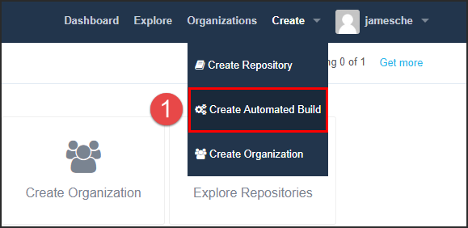

Then you'll need to click on **Link Accounts** to link your GitHub account.



Next, you'll click on **Link Github** to link your GitHub account to Docker Hub.

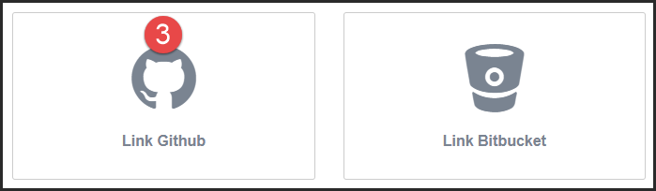

Next, you'll choose between **Public and Private** or **Limited Access**. **Public and Private** is recommended.

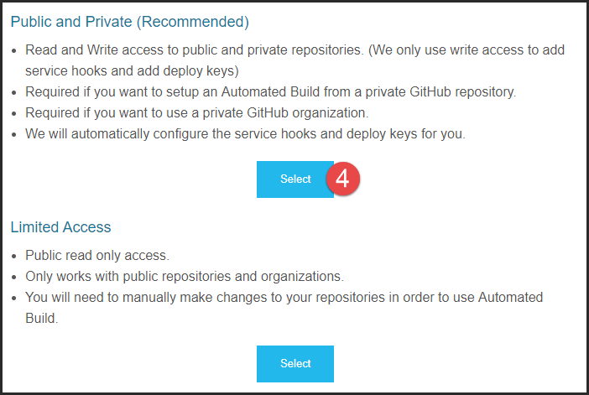

You'll be redirected to GitHub where you'll want to click on **Authorize docker** to complete the connection. (If you aren't logged into GitHub, you'll be prompted to do that first.)

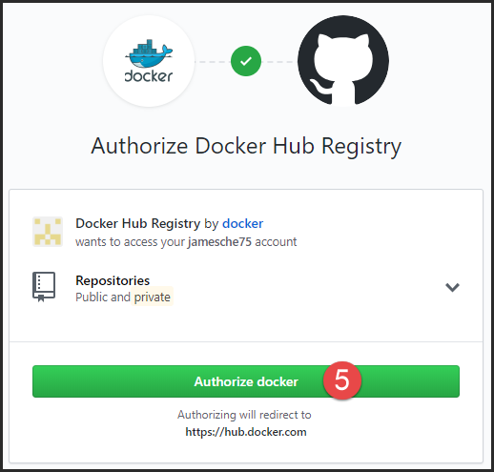

Now you can click on Create, Create Automated Build again and you'll see the option to create an auto-build from GitHub.

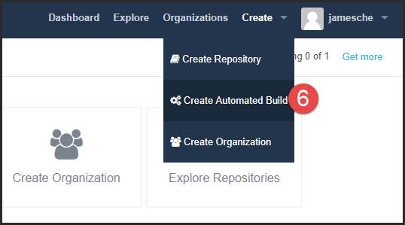

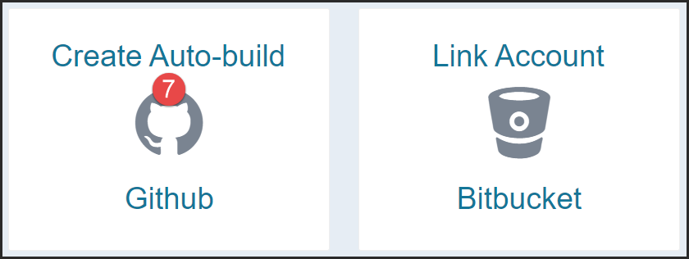

Click on the GitHub repository that you want to use for your Docker image.

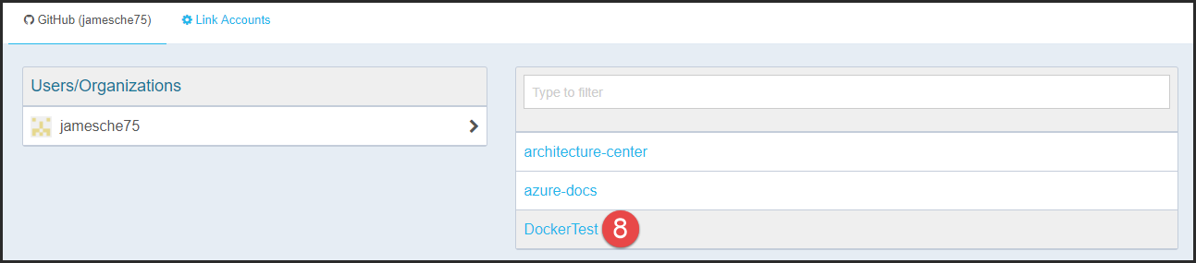

Give your automated build a short description and then click on **Create** to create your Docker Hub repository linked to the GitHub repository.

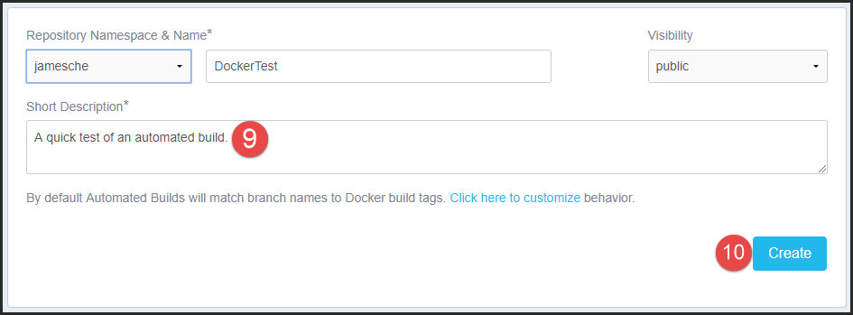

At this point, if you push new changes to your GitHub repository, a new Docker image will be created. However, if you want to create a Docker image from the files currently in the GitHub repository, you'll need to manually trigger your first build.

Click on **Build Settings** in Docker Hub and then click on **Trigger** to trigger a build.

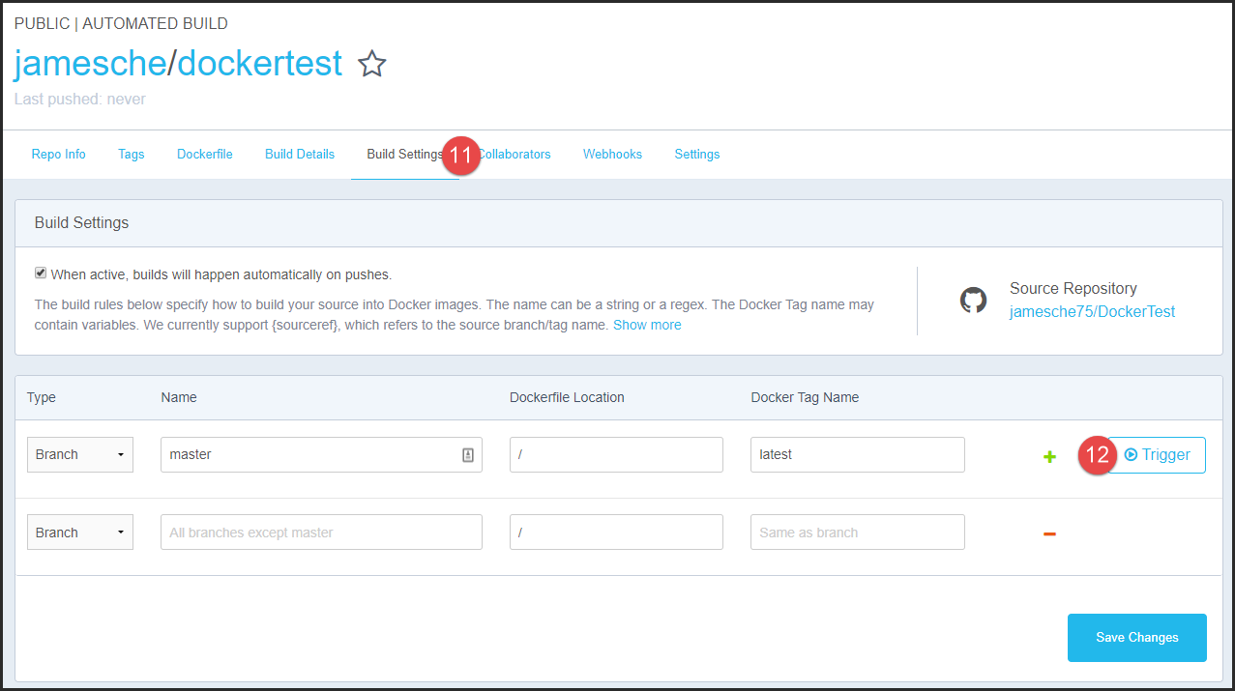

You can view the status of your build by clicking on **Build Details**. Note that the build status isn't updated in real-time, so you'll need to click on **Build Details** to refresh the status.

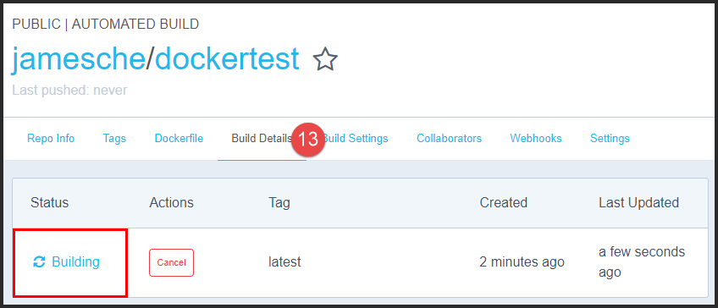

Note that after the initial build, you will not have to manually trigger a build. The automated build will automatically trigger when you push changes to your GitHub repository.

|  |  |
| --- | --- |
| C:\Users\james\AppData\Local\Temp\SNAGHTML53be59c.PNG | You should also configure CI/CD in Web App for Containers at this point. See the **App Service and Linux** module for more details. |

# Multi-Container Deployments

As you've already seen, you can use a Dockerfile to create a container that is based off of multiple parent containers. However, you may also want to separate certain tiers of an application into separate Docker containers.

For example, perhaps you have a database server, a web application, and a caching component to your application. Separating each of these into a separate Docker container provides you with a more efficient means of deploying and updating your application. In such situations, you can use a multi-container deployment. In App Service, we support both Docker Compose and Kubernetes (K8s) for multi-container deployments.

## Docker Compose

Docker Compose allows you to define the *services* that make up an application using a YAML file. Each service equates to a Docker image, and you can specify many settings for each of these images.

A Compose application's services are defined in a Compose file. The Compose file is typically named *docker-compose.yml*, but it's possible to pass your own filename when you start a Compose application.

Below is a simple Compose file that defines two services, *webapp* and *database*.

|  |
| --- |
| version: '3'  services:  webapp:  image: djangoweb  ports: 80  database:  image: mysqldb:weblatest  ports: 3306 |

Once you've defined the services, you start the app using the docker-compose up command.

|  |
| --- |
| $ docker-compose up -d |

When you run this command, Docker will look for a *docker-compose.yml* file in the current directory. If it doesn't find one, an error will result. In order for the app to successfully start, all of the services defined in the Compose file must start. If any of them fails to start, the entire app will fail.

Once the app has started, you can stop the app by running docker-compose down.

## Kubernetes (K8s)

Kubernetes (often referred to as K8s) is another orchestration service that allows you to define a multi-container deployment. In App Service, we support the deployment of K8s *pods* only. A pod is a multi-container app where all containers run on the same host.

Much like a Compose application, a Kubernetes pod is defined using a configuration file. The configuration file can be in JSON format or in YAML format, but in App Service, we support the JSON format only.

Here's a simple pod configuration file.

|  |
| --- |
| apiVersion: v1  kind: Pod  metadata:  name: JimsPod  namespace: WebApp11  spec:  containers:  - image: djangoweb  name: webapp  ports:  - containerPort: 80  - image: mysqldb:weblatest  name: database  ports:  - containerPort: 3306 |

To run the app, run kubectl create and pass in the filename.

|  |
| --- |
| $ kubectl create -f webapp-config.yml |

You can then see the pod by running kubectl get pods.

|  |
| --- |
| $ kubectl get pods  NAME READY STATUS RESTARTS AGE  JimsPod 1/1 Running 0 10m |

To delete a pod (and shut down the app), use kubectl delete.

|  |
| --- |
| $ kubectl delete pod JimsPod |